Focus and Breadth

# Analogy of Visual perception

With visual perception, we have a visual centre, and around that a whole visual field including peripheral vision.

Analogously, in terms of attention, Focus is the centre of our attention, and breadth is everything in awareness.

# Exercise: focus and breadth in visual perception

With the eyes open, try centring the attention

First on just the visual centre (this is easier if your visual centre is resting on some identifiable object rather than just the middle of a blank wall)

Then open the attention to include the whole visual field with no particular emphasis on the centre

Finally, try balancing the two.

# Polarity Map

It’s not that there is a perfect balance between focus and breadth, more that each counters a potential downside of the other:

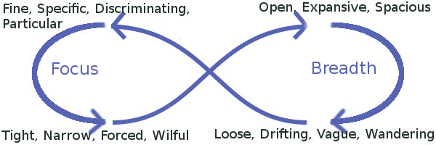

* There are a whole range of positive mental states from a fine discriminating focus to a wide-open receptive breadth.
* There is no need to correct any of these in favour of balance of the two.
* But if your focus gets tight / narrow / wilful then bring in more breadth
* And if your breadth gets vague / sleepy / distracted then bring in more focus

The polarity map of focus and breadth is very similar to that of concentration and relaxation:

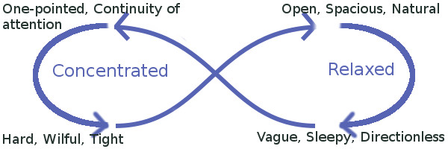

# Exercise: Exploring Focus and Breadth

## Focus

Choose one particular experience to focus on – e.g. the breath at the tip of the nose.

Bring a fine, specific, discriminating awareness to this.

Relax into this focus, see if it is possible for this to be fine, specific, and also soft, relaxed: not tight, narrow, or hard.

## Breadth

Now bring attention to the whole of physical experience,

Opening to the whole body, relaxing into an embodied presence.

Opening also to sounds: just hearing what is audible, not listening to anything in particular.

Opening the eyes, seeing whatever is visible without looking at or engaging the attention with anything in particular.

Noticing

* the quality of openness in the attention and in the awareness
* the intention to open to breadth in this way.
* any sense of doing this exercise in an active / deliberate way.

As you notice each of these, including these qualities in the breadth.