Broad Band of Awareness

# When the band of awareness is narrow

When the band of awareness is narrow, as attention moves/wanders it drops out and we loose the continuity of practice. We’re ‘away’ until called back, eg. by the bell for the next stage.

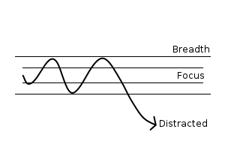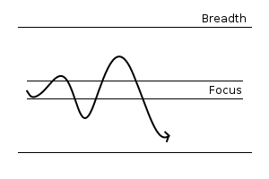

# When the band of awareness is broad

With a broad band of awareness, attention can move/wander without loosing the continuity of practice: movement is allowed. We stay with it.

# Stillness and Movement

* We often think of meditation in terms of stillness, stilling the mind.
* But there is always movement: a continuous process of thoughts, feelings, impressions arising.
* Movement is natural, inherent, intrinsic to the mindfulness. It is not helpful to try to control the mind to prevent movement.

## Analogy of balance

With balance in posture, there are continual small corrections to restore/maintain the balance, what we could call the ‘small dance’

Trying to eradicate all movement leads to a rigid, tight experience with no quality of balance.

The process of balancing is a relaxing and settling in to the balance with awareness.

Movements become subtler, but we’re never completely still.

## A necessary polarity

* In the mind, likewise, both stillness and movement are always there
* Even in the deepest absorption there is still subtle movement
* Even in the most frenetic agitation, not everything moves.
* Stillness and movement are a necessary polarity

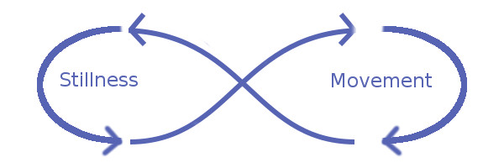

* The practice is knowing how to settle the mind to establish calm and tranquillity whilst allowing movement to occur.
* A broad band of awareness will allow movement to occur – allow the free play of thoughts and feelings to arise – contained in the spaciousness of awareness.
* In contrast, with a narrow constricted awareness thoughts and feelings create disturbance that we’re not able to integrate.
* So if you’re in a disturbed state of mind:
* Broaden the band or awareness-emptiness
* Rather than tightening the focus.

# What not to do

Identifying meditation with stillness, seeing any movement as a distraction leads to a narrow approach that creates a division between

* A protected concentration
* and threatening distractions to be pushed away.

The mind remains tight and constricted, with no deep integration possible because so much experience and energy is excluded.

# What to do

It’s better to open in an undefended way, welcoming and inviting it all in to a broad band of awareness.

The essence of the approach is to keep awareness broad and spacious to allow the free play of movement of thoughts feelings without their disturbing us, allowing it all to settle.