Working in Meditation

Breadth & Focus
- The point of focus needs to be balanced with a broad awareness of sensations, feelings, and mental activity
- Too tight a focus
  - Excluding aspects of our experience – which then seek re-entry as hindrance
  - Tendency to wilfulness, headaches, tension in the body
  - Builds up a resistance to meditation
- Too slack a focus
  - Loss of clarity
    - Distraction (proliferation)
      - Restlessness
    - Vagueness (decay)
      - Torpor
- A balance of breadth and focus is precise, but also integrated. It leads to a deeper level of absorption, because we are meditating with all of ourselves.
- Balance can be integrative: including whatever sensations, feelings, and thoughts arise in to broad awareness and building one-pointedness.

Broad Band of Awareness
- Breadth gives us a band of awareness within which our attention can wander without becoming completely distracted and losing our sense of purpose altogether.
- If our band of awareness is not broad enough, we will become distracted
- With a broad band of awareness we are able to accommodate a wandering attention and gently draw it back to the focus
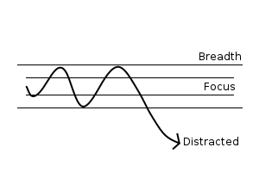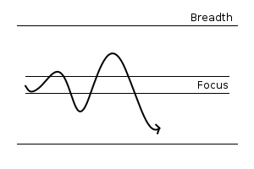
- To be really effective, the broad band of awareness needs to accommodate an awareness of our intention to pay attention. It is this intention that wanders from the focus on to a distraction. We don’t choose to do this: it happens outside of awareness. Bring awareness to attention: the way in which we bring focus to bear. Notice how we are able to establish focus (vitaka) and sustain it (vicara) – and how the it moves unbidden to thoughts, sensations, feelings, sounds other than the intended focus of the practice

Balanced Effort
- In sharpening our focus there is a danger of trying too hard: our effort becomes unbalanced.
- Balanced effort is a quantity: just sufficient to stay focused and a quality: interested, curious, persistent: not wilful or forced. Pliant but steady: a middle way between hard and soft.
- With this balanced approach we look for the quality of concentration and absorption that is present and do what we can to deepen it.
- ‘Concentration’ suggests deliberate effort: ‘Absorption’ suggests effortlessness, a quality of depth and breadth with nothing excluded or left out.
- A balanced effort is an effort that is responsive to our state of mind. The effort balances our tendency to distraction with an intention to pay attention.
  - To be responsive, it needs to be sensitive: feeling in to the texture and quality of our experience of intention and directionality of mind and responding to this.
  - In being responsive, balanced effort is an engagement with the conditioned nature of mind: feeling in to and working with the way that our experience is shaped by our intentions.
  - It is the opposite of a control approach that seeks to pin the attention on a fixed conception of the object (no experience is fixed: only a conception of an object can seem fixed). This control approach is inherently deluded as it does not recognize either the nature of mind or of experience: which is to say it does not come from an understanding of conditionality.

Evam: stillness and movement
The opening word of the Pali suttas (Evam me sutam: Thus have I heard) became in the later tantra a twofold symbol for spaciousness (E) and activity (vam). In the end, for the wisdom of emptiness and the compassionate activity of skilful means that are unified in enlightenment. On a more immediate level, these symbolise the twin characteristics of stillness and movement in the mind. Both stillness and movement are intrinsic to the nature of mind. The mind is never entirely still: there is always some movement, however subtle, even in the deepest states of absorption. Similarly, the mind is never entirely agitated and without stillness. One of the skills in meditation is to learn how to settle the mind whilst allowing movement to occur – without trying to pin it down in a controlling way.
A narrow approach that identifies meditative absorption with stillness sets up a polarity between a protected concentration and the distractions that constantly threaten to break in. This leads to a tight and constricted state of mind without any deeper integration.
As the second Ch’an patriarch put it:
If you try to cease activity to achieve passivity, your very endeavours will fill your mind with activity.

